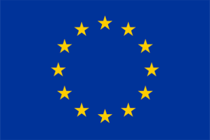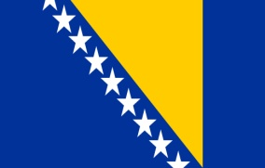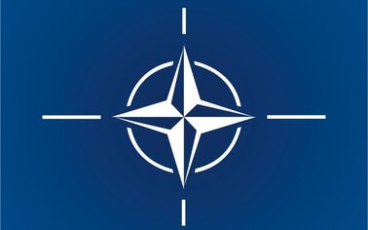

REQUEST
For the Accession of Bosnia and Herzegovina
As Associated member of the European Union

TO:

Martin Schulz Herman Van Rompuy José Manuel Barroso
President of the President of the President of the
European Parliament European Council European Commission

Catherine Ashton ŠtefanFüle
The High Representative European Commissioner
of the Union for Foreign for Enlargement and European
Affairs and Security Policy Neighbourhood Policy

David Cameron Angela Merkel François Hollande
Prime Minister of the Chancellor of Germany President of France
United Kingdome

Your Excellencies / Dear friends,
As You are all aware that the currently valid legislation, set forth by the Dayton Peace Accords, brings the structure of Bosnia and Herzegovina into an irreconcilable collision with the UN Conventions and International Legal Norms, as well as with the basic Civil rights and freedoms, which in itself imposes the necessity of reforms, that are also a requirement for the accession of our country into your membership.

However, due to the Dayton-defined blockage mechanisms in decision-making, it is impossible to implement these reforms in Parliament, because the political will of one, opposes the ideological will of others, who continue to carry out rigid detrimental plans of their mentors from the outside, which brings us, as the citizens of Bosnia and Herzegovina into a nearly hopeless situation.

In order to make improvements in the protection of civil rights, it is necessary, as a start, to incorporate the appropriate laws of the European Union into the Laws of Bosnia and Herzegovina through a special decree by the OHR concerning the fundamental civilization values related to the punishment of the glorification of the backward ideology, as well as the denial of genocide.

The European Union, the United States, the Council of Europe and other leading world democracies, in their parliaments have adopted resolutions of condemnation of the Srebrenica genocide, which have binding responsibilities. Nevertheless, in Bosnia and Herzegovina we are daily witnessing the glorification of fascism and derision of its victims, which directly disparage and violate International law and the Acts of the highest legislative bodies of the afore mentioned countries.

As citizens of Bosnia and Herzegovina, we are proud that, at the time of the Joint Criminal Enterprise and aggression on our territory, accompanied by unprecedented terror and Genocide, our homeland implemented in practice all positive values on which declaratively rests Your community of European states and nations, we are extremely proud of our defenders who, at that time, on the free territory managed to preserve Bosnia, while the aggressors in the occupied territories were destroying the values of the European Union into the ground.

In spite of that and instead of any rightfully deserved awards, our country is punished by forcing the Dayton straitjacket upon it, thus legalizing and legitimizing the anti-civilization fascist ideology that was destroying it, which per se, is a dangerous historical and international-legal precedent.

Your Excellencies / Dear Friends,
Consequently, on behalf of 80 % of Bosnia and Herzegovina's citizens, who according to all the polls that have been conducted, see the future of their country in the European Union, we request that in the interest of sustainable and lasting stabilization and opening of the perspectives for prosperity of Bosnia and Herzegovina and of this part of Europe, bring an immediate and unconditional decision on Admission of Bosnia and Herzegovina into your Associate membership, for a transitional period not exceeding three years.

During the period of three years Your Union with its direct engagement could assist in the implementation of structural reforms and the development of modern Constitution of Bosnia and Herzegovina. The laws deriving from the new Constitution must be harmonized with international conventions in order to formally fulfill the requirements for a full EU membership.

Let us remind you, that Croatia is already a member of the EU and Serbia and Montenegro were granted the Associate status, which we the citizens of Bosnia and Herzegovina, on whose territory according to the verdicts and judgments of the Tribunal in The Hague, an international armed conflict took place, in which the aforementioned neighboring countries participated as aggressors, understand as a very indicative message about the yardsticks of International law and the notion of civil rights and justice as eternal categories.

An additional argument for the admission of Bosnia and Herzegovina into your associate membership is the fact that hundreds of thousands of our citizens, once victims of ethnic cleansing, are now Your citizens, i.e. citizens of the EU, USA, etc.

We believe that Bosnia and Herzegovina should develop a concept modelled on the Marshal Plan, which in addition to the economic, would also include the segments such as government administration, local government and human rights. It is also necessary to establish an Anti-corruption EU-wide body based in Bosnia and Herzegovina, which would address and deal with the tracing of the flows of war-profiteering gains and the postwar economic crime in the region, that according to reliable information, are directed by some of the current holders of political offices and thanks to the mechanism of the so-called Dayton “special ties of entities with neighboring countries” are dislocated from our country into the neighbors countries and vice versa.

We also propose an investigation of whether the Russian investments in Bosnia and Herzegovina and beyond, involves laundering of the Russian mafia money, as they operate worldwide, and in that regard it is necessary to establish an appropriate committee of the EU and the U.S. as we can witness the example of the recent aggression in Ukraine, it is possible that Russia, using that kind of money, funds their expansionistic military machine.

Finally, we would like to emphasize that Bosnia and Herzegovina, as an old European country, is a chance as well as a test for the European Union and the United States to prove their commitment to the basic principles, but also through the accession of Bosnia and Herzegovina into their political and security structures to strengthen their geopolitical position in this part of Europe, that has been increasingly and openly threatened by Russia.

Sincerely,

Edit Agović Hamdija Čustović Luka Markešić
NGO Civic Monitoring Congress of Croatian National Council
North Amerikan Bosniaks of Bosnia and Herzegovina

Emir Ramić Jadranko Odalović Ervin Sendijarević
Institute for Research BCC - Bosnian Civil Council EU Bosnian Cultural Center
of Genocide of Canada

Mehmed Pargan Ismeta Mameledžija Satko Mujagić
CMOK - Center for peace NGO “Youth Prosperity” B&H Platform
education and creativity Nederland

Elvira Kapo Ibrahim Osmanbašić
Foundation “SEDRA” Association for Culture
Netherlands Novo Sarajevo

