Opis fotografije za logor Čelebići

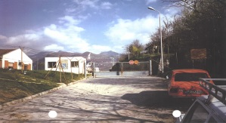
Ulaz u logor ’’Čelebići’’, sa stražarskom kućicom s lijeve strane; fotografiju su snimili MKSJ-a 1995. godine. Logor Čelebići prostirao se na periferiji sela Čelebići, na površini od oko 50 000 metara kvadratnih, a sredinom logora je prolazila željezničk a pruga. Logoraši su dovedeni krajem aprila 1992. godine i većina logoraša je bila zatočena u logoru između aprila i decembra 1992. godine. Svjedoci su izjavili da su ih ispitivali dok su se nalazili u logoru. Neki su izjavili da su tokom ispitivanja bili podvrgnuti fizičkom nasilju.

Entrance to ’’Čelebići’’ Camp with guard house to the left. Photo taken by ICTY investigators, 1995. Čelebići camp was located on the outskirts of the village of Čelebići and covered an area of approximately 50,000 square metres with a railway line running throught the middle. Prisoners were taken to the camp in the latter part of April 1992, and that the majority of the prisoners were detained there between April and December 1992. Many of the witnesses who testified stated that they were interrogated while they were in camp. During their interrogation they suffered physical violence.

Opis fotografije za logor Dretelj
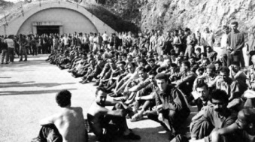
Logor ’’Dretelj’’ se nalazio između Čapljine i Međugorja. Vojnici HVO- a su držale Bošnjake u logoru od aprila 1993. do septembra 1994. Kroz ovaj logor je prošlo preko 3000 logoraša. Logor se sastojao se od šest skladišta. Broj logoraša je bio najveći 11. jula 1993., k ada je HVO držala 2.270 Bošnjak a u zatočeništvu. Nakon toga, prosječan broj logoraša bio je oko 1700. Mnogi od logoraša su bili civili, neki od njih su bile i žene. Logor Dretelj je zatvoren 24. septembra 1994. godine. Logoraše su tukli stražari, vojnici, civili, ko god je stigao. Seksualno su ih zlostavljali, tjerali su ih da se skidaju i jedan drugog oralno zadovoljavaju. Jedan od logoraša k aže: “ Tjerali su me da pijem mokraću i jedem kremu za cipele. Morali smo i travu pasti.” Logor je bio toliko pretrpan da su neki po gredama spavali. Ljudi su od žeđi padali u komu. Jednu bocu vode znalo je piti 20 ljudi, iz čepa. Bošnjaci u izoliranim ćelijama su bili naročito premlaćivani i ponižavani. Najmanje šestero logoraša ubijeno je u tom razdoblju u Dretelju. Međunarodni Crveni križ dobio je dozvolu posjetiti lok aciju tek u septembru 1993. Tada je HVO premjestila neke logoraše u Silos u Čapljini, kako bi prikrila znakove okrutnog psihičkog i fizičkog ponašanja.

’’Dretelj’’ camp was located between Čapljina and Međugorje. HVO soldiers were held Bosniak men in the camp from April 1993. to September 1994. Through this camp passed more than 3000 detainees. The camp had a six warehouses. Number of detainees was the greatest at 11. July 1993., when the HVO held 2,270 Bosniaks in captivity . Af ter that, the average number of detainees was 1700. Many of them were civilians, some of them were women. The camp was closed on 24. September 1994. Detainees were beaten by guards, soldiers, civilians, anyone who wanted to do it. They were sexually abused, forced to be naked and orally satisfying each otherone. One of the detainees said: "They forced me to drink urine and eat shoe polish. We had to eat grass." Camp was so overcrowded that some slept on the beams. People were thirsty and fell into a coma. A bottle of water is drank by 20 people, from the bung. Bosniaks in isolated cells were especially beaten and humiliated. At least six detainees were killed during this period in Dretelj. The International Red Cross has received permission to visit the camp only in September 1993. Then the HVO moved some detainees to Silos in Čapljina, in order to hide the signs of cruel physical and psychological behavior.

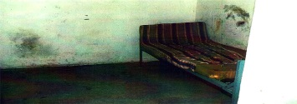

Opis fotografije samice u KP Domu Foča.

Samica u ’’KP domu’’. U jednoj samici je držano i po 18 logoraša.
KP Dom Foča postao je glavni logor za muškarce Muslimane i druge nesrbe. Logoraši u KP Domu uglavnom su bili civili koji nisu optuženi ni za kakav prestup. To su bili muškarci Muslimani starosti od 16 do 80 godina, a među njima je bilo mentalno zaostalih, invalida i teško bolesnih ljudi. Zatvaranje muškaraca Muslimana trajalo je od 1992. do 1994. godine. Svi logoraši su opisivali stalna saslušavanja, premlaćivanja, ubijanja, izolaciju u samicama, prisilni rad i okrutno postupanje. P o dolasku u zatvor , zatvorenike su pretraživali i oduzimana im je imovina. Nekima od njih su prijetili, premlaćivali ih i primoravali da potpišu izjave ili pruže informacije. Mnogi od njih poslije ispitivanja nisu bili u stanju da hodaju ili da govore. Zatvorenici su mogli čuti pucnjeve i neki koje su prethodno odveli u upravnu zgradu nikad nisu vratili. Nakon premlaćivanja, mogli su vidjeti stražare kako u upravnu zgradu unose ćebad, a zatim iznose leševe. Kada bi zatvorenici k asnije ulazili u te prostorije gdje su vršena premlaćivanja vidjeli bi okr vavljene predmete i kr v po zidovima i podu. Na zidovima hodnik a iza metalnih vrata upravne zgrade viđene su rupe od metaka. U septembru 1992. godine oko 30 zatvorenika, od kojih su mnogi bili gladni, javili su se k ao dobrovoljci da beru šljive. Odvedeni su iz KP doma i nik ad se nisu vratili. U jednom od mjesta gdje je vršena ekshumacija nađeni su leševi iz te grupe. Kroz KP Dom je prošlo oko 800 logoraša, 425 ih je ubijeno.

An isolation cell in ’’KP Dom’’, up to 18 detainees were kept in a single cell.
The KP Dom, a prison, was the primary detention center for Muslim and other non-Serb men. The detainees imprisioned at the KP Dom were mostly civilians who had not bees charged with any crime. They were Muslim men between 16 and 80 years of age, including the mentally hendicapped, physically disabled and the seriously ill. Muslim men were detained at the KP Dom from 1992 until the end of 1994. Deteainees described a pattern of interrogations, beatings, killings, solitar y confinement, forced labour and cruel treatment. Detainees after arrival were searched and their property was taken from them. A number were threatened, subjected to beatings and forced to sign statements or provide information. Often, after their interrogations, detainees were unable to walk or talk. Detainees could hear shots and detainees who had been previously taken to the administration building never returned. Af ter the beatings, guards were seen taking blankets into the administration building and removing bodies. Other detainees who later entered the rooms were beatings had taken place saw bloodied instruments and blood on the walls and the floor . Bullet holes were also seen in the walls of the hall behind the metal door to the administration building.In September 1992, some 30 detainees, many of them hungry , volunteered to go picking plums. They were taken from the KP Dom and have never been heard of since. At one of the exumination sites the bodies of two persons who were found. Throught this camp were passed 800 detainees, 25 was killed.

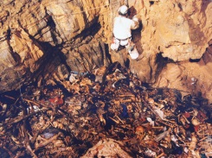

Opis fotografije jama Hrastova glavica

’’Hrastova glavica’’ je prirodna jama duboka više od 20 metara, kod sela Podvidača, opština Sanski Most . Skeletni ostaci iz jame ekshumirani su 1998. godine. Neka od tijela koja su pronađena u jami su donešena u dekama do otvora jame, a zatim su bačena u jamu. Pošto je otvor na jami bio vrlo uzak, većina tijela bila je nagomilana na tlu u sredini jame. Na vrhu gomile tijela i blizu ulaza u jamu bilo je nekoliko deka koje su djelomično pokrivale nekoliko tijela. U ranim jutarnjim satima, 5. augusta 1992., Radovan Vokić, vozač Sime Drljače je tražio od stražara da dovedu do autobusa logoraše iz Keraterma , koji su tu dovedeni prethodnog dana iz prijedorskog logora Omarska. U njegovom vlasništvu je bio spisak logoraša, koji je pažljivo sastavljen, ovjeren i potpisan od strane Sime Drljače. Najmanje 120 ljudi je prozvano. Oni su postrojeni i potrpani u dva autobusa koja su pod pratnjom otišla prema Kozarcu. Autobusi koje su koristili su bili sredstva javnog prijevoza u Prijedoru. Svjedok E sastavio je popis od oko 60 ljudi koje je poznavao lično, a koji su odvedeni ovim autobusima i ubijeni. Leševi nekih od tih ljudi su kasnije pronađeni u jami Hrastova Glavica i identifik ovani. Veliki broj tijela, 126, pronađen je na ovom području, što je oko 30 kilometara od Prijedora. U 121 slučaju, for enzički stručnjaci utvrdili su da je uzrok smrti bila rana od vatrenog oružja.- Iz presude Stakiću

„Hrastova glavica“ (The Oak Head) is a natural cave, deep more than 20 meters, near the village of P odvidača, Sanski Most municipality. The skeletal remains were exhumed from a cave in 1998. The bodies of the individuals contained of the cave were brought to the cave entrance on blankets and then dropped down into the cave. As the chamber was very narrow , most of the bodies piled in the centre of the cave floor . On the top of the pile of bodies and close to the entrance of the cave were a few blankets that partially covered several of the bodies. In the early morning of 5 august 1992, Radovan V okic, Simo Drljaca's driver asked guards around to bring to the buses detainees fr om Keraterm who had been brought ther e the previous day fr om Prijedor to the Omarska Camp. He was in possesion of a list of detainees, which had been carefully compiled, writen out and signed by Simo Drljaca. At least 120 people were called out. They were lined up and put on two buses which drove away towar ds Kozarac under escort. The buses used were the usual public transportation buses in Prijedor . Witness E compiled a list of about 60 people he know personally who were taken away on these buses and killed. The corpses were later found in Hrastova Glavica and identified. A large number of bodies, 126, were found in this area, which is about 30 kilometers away fr om Prijedor. In 121 of the cases, the for ensic experts determined that the cause of death was gunshot wounds.- Stakić Judgement

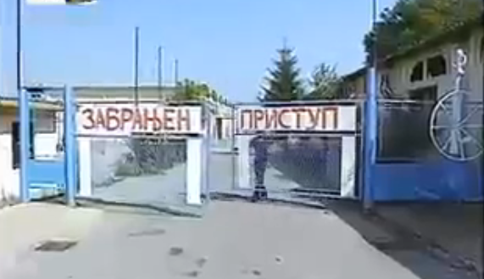

OPIS ZA LOGOR LUKA

Logor „Luka“ bio je najzloglasniji srpski koncentracioni logor na brčanskom području. Logor je uspostavljen 02. maja 1992. godine, a kroz njega je prošlo preko 3000 Bošnjaka i Hrvata. Logoraši su sistematski mučeni, maltretirani i ubijani. Uslovi i postupci kojima su podvrgavani logoraši bili su užasni i podrazumijevali su redovna premlaćivanja, silovanja i ubistva. Prema izvještaju Ekspertne komisije za istraživanje kršenja međunarodnog humanitarnog prava Ujedinjenih nacija, “nekoliko stotina muškaraca“ ubijeno je u logoru Luka i “bačeno u rijeku Savu“. Četnici su mogli birati koga, na koji način i koliko dugo žele ubijati. Ponekad su igrali “Igru smrti”. Igra bi počinjala uveče. Četnici bi dovezli automobil u hangar i naredili logorašima da trče oko automobila. Za vrijeme trčanja udarali bi ih palicama, sabljama i drugim predmetima. U jednom trenutku, kada bi se začula komanda “STOP ”, upalili bi svjetla na autu. Onaj ko je osvijetljen svjetlošću farova bivao je osuđen na smrt. Logoraši su spavali na komadima papira, bez pokrivača. Krici mučenih ljudi nisu prestajali dan i noć. Zločinci su sjekli logorašima nosove, uši, prste; parali im utrobe razbijenim bocama; ubijali ih čekićem, sjekirom, tupim predmetima…

„Luka“ camp was the most infamous Serbian concentration camp in Brčko area. The camp was
established on 02. May 1992., where more than 3,000 Bosniaks and Croats were detained. The detainees were systematically killed, tortured, beaten and otherwise mistreated. The conditions and treatments were appalling and entailed the regular executions, beatings and rape. According to the report of the UN Expert Commission for investigation of violations of international humanitarian law, "hundreds of men" were killed in the Luk a camp and "thrown into the Sava River." Chetniks could chose whom, how, and for how long they wanted to kill. Sometimes they have played the "Game of Death". The game was started in the evening. Chetniks drove the car to the hangar, and then ordered to the detainees to run around the car. During the running, they beat them with batons, sabers and other objects. At one moment, when the command "STOP" was heard, they turned on the lights on the car. Anyone who has been illuminated by a light headlight was sentenced to death. The prisoners slept on pieces of paper, with no cover. The screams of tortured men did not stop day and night. P erpetrators of detained Bosniaks were cutting their noses, ears, fingers, cutting them womb using broken bottles, killing them with a hammer, ax, blunt objects…

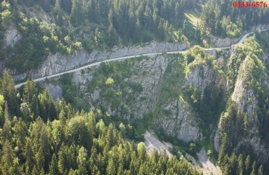

OPIS FOTOGRAFIJE ZA KORIĆANSKE STIJENE

Put kojim se kretao konvoj od logora Trnopolje do Korićanskih stijena gdje je streljano više od 200 muškaraca. Dvanaest ljudi je preživjelo strijeljanje i pad u provaliju, visinskog raspona 300 metara. Ekshumacije su vršene 2003. i 2009. godine. Najveći broj posmrtnih ostataka žrtava još uvijek nije pronađen. Tijela do sada identifik ovana uglavnom nisu kompletna. „Dana 21. augusta 1992., u logor Trnopolje su počeli pristizati autobusi i logorašima je rečeno da se u njih ukrcaju. Natrpano ih je po stotinjak u jedan autobus. Vlašić je bio prepoznatljiva tačka na putu ka odredištu, odnosno liniji razdvajanja između srpske i muslimanske teritorije prema Travniku. Konvoj je izašao na put kojem su s jedne strane bile strme stijene, a s druge dubok a provalija. Autobusi su se zaustavili. U pratnji konvoja je išao izvjestan broj policijskih vozila. Muškarcima je naređeno da izađu i krenu ka ivici provalije, a tamo im je rečeno da kleknu. Onaj čovjek za kojeg se činilo da je glavni je rekao: „Ovdje mi mijenjamo mrtve za mrtve i žive za žive.“ Tada je počela paljba. Dva vojnika su se spustila na dno provalije i pucala ljudima u glavu. T o područje se zove Korićanske stijene“.- Iz presude Stakiću.

The road on which the convoy was moving from the Trnopolje camp to Koricanske stijene, where was killed more than 200 men. Twelve people survived the execution and falling into the abyss, the altitude range of 300 meters. Exhumations were in 2003 and in 2000. The largest number of remains of victims still not found.The Bodies that have been identified are mostly not complete. „On 21 August 1992, buses started to arrive in the T rnopolje camp and the detainees were told to board them. There were approximately 100 people packed onto each bus. Mount Vlasic was a landmark on the way to the final destination which was the line of separation between Serb and Muslim controlled territory in the direction of Travnik. The convoy drew up on a road flanked on one side by a steep cliff and on the other by a deep gorge. The convoy was accompanied by a number of police vehicles. The men were ordered to get out and walk towards the edge of the gorge where they were told to kneel down. The individual who appeared to be in charge said: “Here we exchange the dead for the dead and the living for the living.” Then the shooting began. T wo soldiers went to the bottom of the gorge and shot people in the head. The area is known as Koricanske Stijene“.- Stakić Judgement

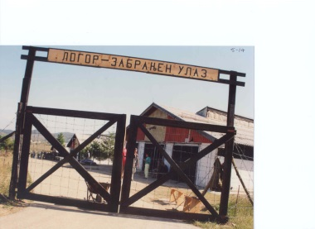

OPIS ZA LOGOR MANJAČU

Logor ’’Manjača’’ je bio koncentracioni logor smješten na brdu Manjači u blizini grada Banja Luke. Logor je osnovan od strane srpskih vlasti i vojnih snaga (VRS), a koristio se za zatvaranje i ograničavanje hiljade logoraša bošnjačke i hrvatske nacionalnosti. Logor Manjača je počeo sa radom 15. maja 1992. godine. Zatvoren je pod međunarodnim pritiskom krajem 1993. godine, ali je ponovno otvoren u oktobru 1995. Procjenjuje se da je u to vrijeme više od 5000 nesrba, prvenstveno sa područja Sanskog Mosta i Banja Luke, prošlo kroz logor. Kada su 1995. bosanske vlasti preuzele logor, pronađeno je 85 leševa povezanih sa ubistvima u logoru. Ukupan broj logoraša ubijenih u logoru Manjača nije poznat. Međunarodni sud pravde je izjavio da je u neposrednoj blizini logora pronađena masovna grobnica s 540 tijela. Broj logoraša se udvostručio u oktobru 1992. nakon što su mnogi prebačeni iz prenapučenog logora Omarska koji je zatvoren zbog međunarodnog pritiska. Logor Manjača je bio okružen bodljik avom žicom, tornjevima, minskim poljima i psima.

’’Manjača’’ camp was a concentration camp which was located on mount Manjača near the city of Banja Luka. The camp was founded by the Serbian authorities and military forces and was used to collect and confine thousands of detainees of Bosniak and Croat nationalities. Manjača began operating as a detention camp on 15 May 1992. The camp was shut down under international pressure in late 1993 but was reopened in October 1995. At that time it was estimated that a total of more than 5000 non-Serbs primarily from the Sanski Mosta and Banja Luk a areas passed trought the camp. When the camp was captured in 1995 by Bosnian authorities, some 85 corpses were found associated with killings at the camp. The number of killed in Manjača camp is unknown. The International Court of Justice stated that near the camp found a mass grave with 540 bodies. The number of detainees has doubled in October 1992., because many of detainees were transferred from the overcrowded Omarska camp, which was closed due to international pressure. Manjača camp was surrounded by barbed wire, towers, minefields and dogs.

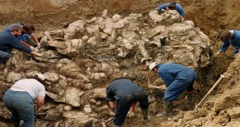
OPIS ZA GROBNICU TOMAŠICA

Masovna grobnica „Tomašica“ je najveća primarna masovna grobnica u BiH. U 2013. godin ekshumirani su posmrtni ostaci 430 žrtve (275 kompletnih tijela). Među tijelima su otkriveni muškarci raznih životnih dobi i žene. Obzirom na glinovito tlo u T omašici, mnoga tijela i nakon 20 godina gotovo imaju kosu, nokte, pa čak i tkiva. Tijela žrtava 1992. godine na Tomašici zakopavana u tri mjeseca, a u zločinačkim radovima učestvovalo je više stotina ljudi sa mašinama. Tragično je da su i neki logoraši iz prijedorskih logora bili primorani prenositi leševe, a nakon toga su i sami bili likvidirani, što potvrđuju i pronađena zrna metaka kod masovne grobnice . Ovdje su bila sakrivena tijela više od 800 žrtava, od kojih je dio prebačen u sekundarnu Masovnu grobnicu „Jakarina kosa“. Ove dvije grobnice povezane su na temelju DNK analize, jer su dijelovi tijela ubijenih civila pronađeni na obje ove lokacije.

„Tomasica“ Mass grave is the largest primary mass grave in Bosnia and Herzegovina. In 2013. were exhumed skeletal remains of 430 victims (275 complete bodies). Among the bodies were men of various ages and women. Due to the clayey soil at T omasica, these bodies still have a hair, nails and tissues. Bodies were thrown into Tomasica in summer of 1992, and in criminal intents participated several hundred people with machines. It is tragic that some detainees from Prijedor camps were forced to carr y the corpses, and after that they were killed, as confirmed by the grain bullets found at mass grave in Tomašica. There were hidden bodies of more than 800 victims, and some of them were transferred to the secondar y mass grave "Jak arina kosa". These two mass graves are connected based on DNA analysis, because the same parts of bodies found at both these locations.

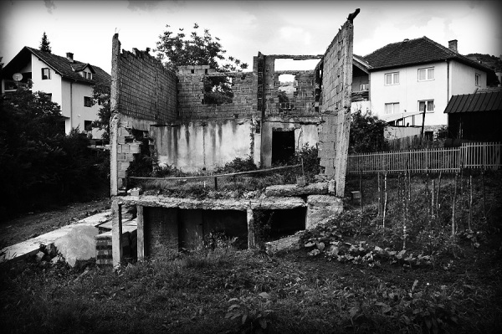

OPIS FOTOGRAFIJE „ŽIVA LOMAČA“ U VIŠEGRADU
"Živa lomača" – mjesto gdje je živo spaljeno više od 70 civila bošnjačke nacionalnosti, 14. juna 1992. godine., Pionirska ulica, Višegrad.

„ Living bonfire“- the place were Bosnian Serb paramilitary forces burnt alive more than 70
Bosniak civilians, on 14 June 1992., Pionirska street, Visegrad

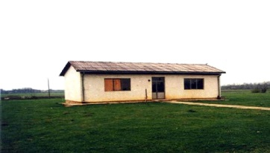
OPIS FOTOGRAFIJE „BIJELA KUĆA“ U LOGORU OMARSKA

Logor Omarska - „Bijela kuća“ - korištena je za pritvaranje posebnih logoraša, tzv. političkih zatvorenika. Politički zatvorenici su bili članovi bosanske muslimanske policije i druge utjecajne osobe u Prijedoru. Tukli su ih, iz dana u dan i iz noći u noć. Posjetitelji logora i logorski čuvari su u ovoj zgradi počinili najveće strahote. Uslovi u logoru bili su užasni. U zgradi koju su zvali
“Bijela kuća” bilo je po 45 ljudi u prostorijama ne većim od 20 kvadratnih metara. Lica logoraša bila su izobličena i krvava, a na zidovima je bilo kr vi. Logoraše su već prve večeri tukli pesnicama, kundacima i drvenim i metalnim palicama. Kad su nekog htjeli pretući nasmrt, stražari su mahom udarali u predjelu bubrega i srca. Ljudi su bili “natrpani k ao sardine”, a vrućina je bila neizdrživa. Pr vih nekoliko dana logoraši nisu smjeli izlaziti i dobivali su samo po kanister vode i nešto hljeba. Dešavalo se da se ljudi preko noći uguše, a njihova tijela su iznošena sutradan ujutro.Svako jutro je bila hrpa mrtvih tijela naslaganih ispred "Bijele kuće". Dolazili bi kamioni na koja bi se tijela ukrcavala te odvožena u nepoznatom pravcu.

Omarska camp- “the White House” - used to detain special prisoners, so-called political prisoners. The political prisoners included Bosnian Muslim members of the police and other influential persons throughout the municipality. They were beaten day after day and night after night. Visitors to the camp and camp guards would go into this building and commit the utmost horrors. The conditions in camp were appalling. In the building “White House”, the rooms were crowded with 45 people in a room no larger than 20 square meters. The faces of the detainees were distorted and bloodstained and the walls were covered with blood. As early on as the first evening, the detainees were beaten, with fists, rifle butts and wooden and metal sticks. The guards mostly hit the heart and kidneys, when they had decided to beat someone to death. P eople were “packed like sardines” and the heat was unbearable. For the first few days, the detainees were not allowed out and were given only a jerr y can of water and some bread. Men would suffocate during the night and their bodies would be taken out the following morning. Every morning there were piles of dead bodies stacked up in front of the “White House”. Trucks would come the bodies would be loaded onto them and taken away to an unknown destination.

OPIS LOGORA U ODŽAKU
Logor u Osnovnoj školi u Odžaku. – U periodu od 08. maja do sredine juna 1992. godine, za vrijeme oružanog sukoba u Bosni i Hercegovini, pripadnici HVO-a su držali civile srpske nacionalnosti, koji su bili nezakonito zatvoreni u prostorijama Osnovne škole Odžak i u tvornici „Strolit“ u Odžaku. Civili u logoru su svakodnevno bili izloženi nečovječnom postupanju, psihičkom i fizičkom zlostavljanu, ubijanju i drugim nedjelima tokom 1992. godine.

The Elementary school camp in Odžak. – During the period from 08 May 1992 until mid July 1992, during the armed conflict in Bosnia and Herzegovina, members od the Croat Defense Council (HVO) detained a civilians of Serb nationality, who were unlawfully detained in the Elementary school and „Strolit“ factor y in Odžak. The civilians in the camp were daily exposed to inhumane treatment, mental and physical abuse, murder and other misdeeds during 1992.

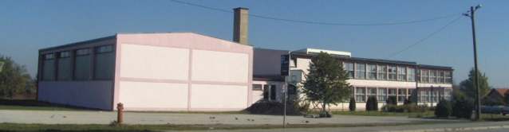

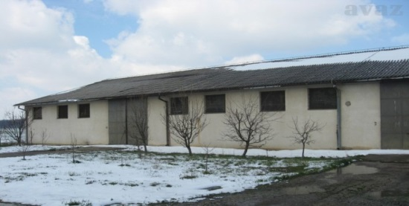
OPIS FOTOGRAFIJE LOGOR BATKOVIĆ
Logor Batković je bio smješten na poljoprivrednom dobru u selu Batković, udaljen 12 km od grada Bijeljine. F ormiran je u aprilu 1992. godine, od strane Jugoslovenske narodne armije. Logoraši su bili civili bošnjačke i hr vatske nacionalnosti. U logoru je bilo maloljetnika i starijih ljudi. Logoraši su dovođeni iz više opština u BiH: Banja Luk a, Prijedor , Bosanski Novi, Sanski Most, Ključ, Kotor V aroš, T eslić, T ravnik, Doboj, Kupres, Jajce, Mrkonjić, Bosansk a Gradiška, Derventa, Bosanski Šamac, Brčko, Modriča, Kalesija, Bijeljina, Zvornik, Vlasenica, Šeković, Janja, Koraj. 30. jula 1992. godine u logoru je bilo 740 logoraša. Mnogi logoraši su ubijeni u logoru u ovom početnom periodu. Procjenjuje se da je u ljetnom periodu u logoru bilo između 1500-2000 ljudi. P o raspuštanju logora Manjača, 13. decembra, u logor Batković su prebačene 532 osobe. Logoraši su bili smješteni u dvije hale (površine 50x20 metara), okruženi sa tri strane bodljikavom žicom. Logoraši su boravili u nehumanim uslovima, spavali su na betonskom podu prekrivenom malim količinama slame, u hangarima koji se nisu grijali zimi i koji nisu imali struju. Lična higijena je također bila onemogućena. Na visokim osmatračkim tornjevima čuvari su bili danonoćno, k ako bi spriječili bilo kakav pokušaj bijega. Zlostavljanje i mučenje zatočenih civila bila je svakodnevna pojava. Grubo premlaćivanje svim vrstama predmeta, trajalo je satima i bilo sasvim uobičajeno u pr vim mjesecima postojanja logora, neki su ljudi bili premlaćivani i do deset puta na dan. Kroz logor Batković je prošlo preko 2500 logoraša.

Batkovic camp was placed on a farm in the village of Batkovic, 12 km away from the town of Bijeljina.
Batkovic Concentration Camp was formed in April of 1992. by the Yugoslav National Army. The detainees in Batkovic Camp were all civilians of Bosniak and Croatian nationality. There were minors and elderly man in the camp as well. The detainees in this camp were brought from various municipalities in Bosnia and Herzegovina: Banja Luka, Prijedor, Bosanski Novi, Sanski Most, Kljuc, Kotor Varos, Teslic, Travnik, Doboj, Kupres, Jajce, Mrkonjic, Bosansk a Gradiska, Derventa, Bosanski Samac, Brcko, Modrica, Kalesija, Bijeljina, Zvornik, Vlasenica, Sekovic, Janja, Koraj. By the 30th of July 1992 there were 740 inmates. Many prisoners were killed in this initial period. It was estimated to be between 1500-2000 people in the camp during the summer of 1992. On the 13th of December, after the dissolution of camp Manjaca, 532 persons were transported to Batkovic Concentration Camp. Detainees were being held in two warehouses (50x20 meters). These buildings were surrounded on three sides by barbed wire. They were placed in horrific accommodation conditions. Detainees slept on a concrete floor covered with small quantities of straw, in hangars that were not heated in winter and witch had no electricity. Personal hygiene was also disabled. Guards were positioned on high watch towers around the clock in order to prevent any kind of escape. Abuse and torture of imprisoned civilians was a daily occurrence. Rough beating with all kinds of objects that lasted for hours was quite common in the first months of the camps existence when some people were beaten up to ten times a day. Through this camp were passed more than 2500 detainees.

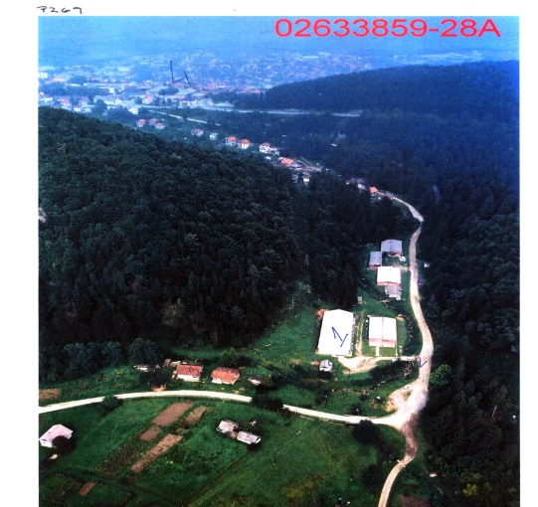
OPIS FOTOGRAFIJE LOGOR SUŠICA U VLASENICI

Logor „Sušica“ je osnovan krajem maja 1992. godine od strane srpskih vojnih snaga za Bošnjake i ostale nesrbe iz opštine Vlasenica. Logor se sastojao od dvije glavne zgrade i jedne manje kuće. Logoraši su bili smješteni u skladištu ili hangaru dimenzija 50x30 metara. Od kraja maja do oktobra 1992. godine, više od 8000 bošnjačkih civila i ostalih nesrba iz Vlasenice i okolnih sela je bilo zatočeno u logoru Sušica. Broj logoraša u hangaru po pravilu se kretao između 300 i 500 ljudi. Zgrada je bila pretrpana logorašima, a životni uslovi očajni. U logoru su držani muškarci, žene i djeca, ponekad i cijele porodice. Muškarce su držali u logoru sve do kraja septembra 1992. godine, a onda su ih premjestili u veći logor Batković, kod Bijeljine. Žene svih dobnih skupina su silovane i sekusalno zlostavljane za vrijeme držanja u logoru, od strane stražara ili ostalih muškaraca kojima je bilo dozvoljeno da ulaze u logor . Muškarci u logoru su proživjeli istu sudbinu k ao i žene. Oni su maltretirani, mučeni i ubijani. Prema riječima P ere P opovića, bivšeg stražara u logoru, oni su ih uglavnom postrojavali pored električnog stuba ispred baraka i strijeljali. Logoraše iz Sušice su odvodili na prislini rad, često i u živi štit. Više od 1600 logoraša je ubijeno u logoru od strane stražara ili je umrlo od posljedica maltretiranja. Masakr je počinjen u toku noći 30. septembra 1992. godine, kada je 150 logoraša iz logora Sušica autobusima odvezeno i streljano.

The „Susica“ camp was a detention camp set up on late May 1992 by Serb forces for Bosniaks and other non-Serbs in the Vlasenica municipality. The detention camp comprised two main buildings and a small house. The detainees were housed in a hangar which measured approximately 30x50 meters. Between late May and October 1992, as many as 8,000 Bosniak civilians and other non-Serbs from Vlasenica and the surrounding villages were successively detained in the hangar at Susica camp. The number of detainees in the hangar at any one time was usually between 300 and 500. The building was severely overcrowded and living conditions were deplorable. Men, women and children were detained at the camp, sometimes entire families. The men were held in the camp until its closure in late September 1992, and were then transferred to the larger Batkovic Detention Camp near the town of Bijeljina. Women of all ages were raped or sexually assaulted during their time in the camp by camp guards or other men who were allowed to enter the camp. Male detainees of the camp suffered a similar fate as the women. They were bullied, tortured and murdered. According to Pero Popovic, a former guard at the camp, they were generally lined up against an electricity pylon just outside the barracks and shot. Detainees at Sušica performed forced labour, sometimes at the front lines. Some detainees were killed by camp guards or died from mistreatment. A massacre was committed during the night of 30 September 1992, when the remaining 140 to 150 detainees at Sušica camp were driven out of the camp with buses and executed.

