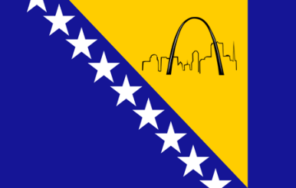

**Bosnian Chamber of Commerce**

**& United Bosnian Association**

**P. O. Box 2761, St. Louis, MO 63116**



August 18, 2014

Emir Ramic

Director

The Institute for Research of Genocide – Canada

Dear Mr. Ramic,

**Re: 10th Traditional Bosnian Festival At Sebilj – Sunday, August 31st, 2014**

The Bosnian Chamber of Commerce and the United Bosnian Association are proud to announce that the **Traditional** **Bosnian Festival** will be at **Sebilj Fountain** (Gravois & Morgan Ford). Due to the tremendous success of the Traditional Bosnian Festival 2013 we are anticipating another great response from local vendors as well as a higher attendance rate.

**Traditional Bosnian Festival** will be held on:

**Sunday, August 31st, 2014 from 11am – 9pm.**

**Traditional Bosnian Festival** will take place at **Gravois and Morgan Ford.** It will introduce and reacquaint visitors to the many Bosnian businesses and restaurants in our neighborhood, help vendors promote their business and grow their customer base for future success. There will be events and performances by Kud Djerdan, traditional Bosnian Folk dance group, a band and entertainment for the children; food, drinks and many more events planned.

**Highlighting this year’s gala event will be the dedication of the Sebilj Fountain our gift to St Louis for our City’s 250’th Birthday. The original Sebilj Fountain is located in Sarajevo, capital city of Bosnia & Herzegovina. Built by Mehmed Pasa Kukavica in 1745 during the Ottoman Empire and is still operational.**

We would love to have you come and say a few words.

For more information please contact Anela Barbanell at 314-757-5000 or Sadik Kukic at 314-757-5000.

Sincerely,

Sadik Kukic, President Anela Barbanell, President

**Bosnian Chamber of Commerce United Bosnian Association**