The Whistleblower –
How a Holocaust survivor blew the whistle on genocide

The following is a true story from the Balkans, proving once again that life really is stranger than fiction. Many of the men and women involved in the events described below remain extremely reticent to speak openly about the past, especially with this snoopy American journalist. Their ongoing silence speaks volumes. And silence is not always golden.

Robert Leonard Rope, November 2014

What comes to mind when you hear the word “whistleblower”? Is it the image of youthful NSA insider Edward Snowden releasing a slew of top secret documents about America’s overarching and ubiquitous ‘security’ program, only to go into hiding in Vladimir Putin’s Russia? Or perhaps you think back to those intrepid Washington Post journalists Bob Woodward and Carl Bernstein, famously blowing the whistle on Richard Nixon and his fumbling band of Watergate burglars with the collaboration of the aptly-named Deep Throat. Not to mention the feisty eco-whistleblower and human rights crusader Erin Brockovich, so glamorously portrayed on film by Julia Roberts, who blew the lid off of corporate greed and mass poisoning of our all too vulnerable environment.

This is the story of a different kind of whistleblower. His real name was Oskar Kliper, but the world at large knew him as Dragan Vitomirovic (Vi-to-meer-oh-vich). Dragan was a complicated and driven man with a unique life trajectory: Holocaust survivor, Yugoslav spymaster, and finally, investigative, whistle-blowing journalistic crusader.

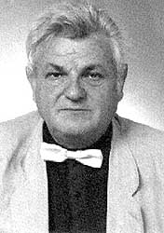

Dragan Vitomirovic, c. 1989 (Vreme)

During the final chapter of Slobodan Milosevic’s reign of Balkan terror, Dragan discovered the uncomfortable and dangerous truth about a sunken refrigerator truck that had inadvertently surfaced from the icy waters of the Danube in April, 1999, full of mangled corpses. Vitomirovic, the determined Serbian born truth-teller, could not stop talking and writing about that nightmarish discovery - that hellish apparition. And for that determination he paid a very high price, indeed.

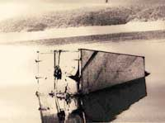

Freezer truck that surfaced from the depths of the Danube, April 1999 (Free Serbia, 2001)

Oskar Kliper’s family did not have especially deep roots in Serbia. His Eastern European Ashkenazic ancestors had originated from Wiznitz, in present day Ukraine. Sometime during the late 19th century they managed to escape the relentless plague of anti-Semitic, Czarist-era pogroms and persecution. While a part of the family found temporary refuge in what was then considered highly civilized Germany, Oskar’s paternal great grandparents made their way to the Bosnian capital of Sarajevo, with its long established reputation of welcoming persecuted Jews since at least the bad old days of the Spanish Inquisition.

By 1914, Sarajevo had become a kind of Ground Zero for the upcoming Great War. Serbia’s quasi-official state terror group, Black Hand, had helped surreptitiously fund and organize a group of idealistic and largely destitute young men to assassinate the heir to the Austro-Hungarian throne, Archduke Ferdinand, who had embarked, together with his beloved wife Sophie, on a state visit to Sarajevo. The assassination raised tensions in Bosnia and throughout Europe to a boiling point. Oskar’s grandparents once again fled, this time for the relative safety and security of Eastern Serbia, and a small town called Zajecar.

Fast forward some 25 years. Following Hitler’s dramatic ascent to power and the noxious spread of fascist ideology, no corner of Europe proved safe for Jews. In 1939, propelled by the ominous spread of native Balkan anti-Semitism, Oskar’s father changed his name from Ernest to Vitomir. Then in 1941, upon Nazi Germany’s invasion of Yugoslavia and Serbia’s subsequent occupation, “Kliper” became fully Serbianized. Oskar Kliper was now magically transformed to Dragan Vitomirovic.

Tragically, none of these superficial changes were sufficient to save the family. At some point in 1942, Dragan’s male family members - among them his beloved grandfather, uncle and father - were rounded up by the Nazis, with the full support and cooperation of Serbia’s collaborationist puppet regime. They were subsequently forcibly taken to Belgrade and shot en masse together with hundreds of other Jewish men at the bloody killing fields of Jajinci.

By August 1942, German administrator Harald Turner was famously able to boast that Serbia was supposedly Judenfrei - ethnically cleansed of Jews, together with thousands of Roma. From the beginning, Serbian native fascists took an active role in helping to round up Jews, Roma and other targeted Serbs and minorities. Even primitive mobile poison gas vans were put into operation in this evil frenzy, colloquially referred to inside Nazi-era Serbia as Dusegupka, or ‘soul killers.’ The toxic vans methodically gassed to death thousands of Jewish women and children while driving through the streets of Belgrade - a precursor to the vile, assembly line gas chambers of Auschwitz and other Nazi extermination centers. These mobile killing units would find a haunting echo in the corpse-carrying refrigerator transport convoys of the 1990s.

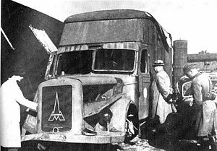

Nazi mobile poison gas van used to murder Jews and “undesirables” during WW2 (Wikipedia.org)

But how did young Dragan survive, when millions of Jewish children perished across Europe? It turns out that Dragan’s mother was ethnically Serb – she and Dragan were protected and hidden by Serb relatives and friendly Serb neighbors. His parent’s mixed marriage and his own ‘mixed blood’ allowed him to survive the surrounding inferno.

Dragan never forgot the central tragedy of his family. According to his son Miljan, that became the determining factor in his life and career, the leitmotif of his existence. From that moment on, Dragan was bent on seeking justice. It was that righteous obsession that eventually led him to landing a position with Tito’s State Security Service. Recalls Miljan: “That was what allowed my father to determine who was responsible for his father’s murder - who put the signature on the document.”

Dragan eventually located the man in Germany, in 1969, living free and easy and without any apparent fear of prosecution. He had been the Nazi commander of the town of Zajecar, and responsible for the extermination of the core of Dragan’s family. “What happened in Germany?” I tentatively inquired. “Dragan killed him by wire and took his revenge,” was Miljan’s enigmatic response.

Tito - Yugoslavia’s post-war leader (Time,1955)

But the drama in Dragan’s life had only just begun. After Tito died in 1980 and Yugoslavia began to fracture, Dragan nervously witnessed the reemergence of Serbian fascism, this time under the auspices of the ruthless and cynical Slobodan Milosevic. But unlike so many other Serbian leaders and intellectuals, Dragan was never taken in by the Milosevic mystique.

In 1987, as Milosevic was consolidating his hold on power, Dragan penned a series of reports critical of Serbian policies in its then province of Kosovo. He had clearly come to see the inherent dangers of Serbia’s regressive policies, up close and personal, and advised Serbia’s government to fully engage the emerging young Albanian leaders like Azem Vlasi, and to promote civil democracy, all in a desperate effort to preserve Yugoslavia.

For his troubles and efforts, Dragan became persona non grata in official Belgrade circles. After an unauthorized visit to his Aunt Rosa in Haifa, Israel, Vitomirovic was directly accused of being “an Israeli spy.” He was subsequently denounced and kicked out of state service, destroying a respected career and losing a potentially lucrative state pension. In Milosevic’s Serbia, Dragan Vitomirovic was suddenly on his own, protected and probably saved, as Miljan recalls, by one of his supportive and influential colleagues.

During the ensuing fighting and bloodbaths in Croatia and then Bosnia, Miljan states unequivocally that his father adamantly refused to follow blindly the mass nationalist hysteria, despite the overwhelming pressures. “He was disgusted by what he saw happening in Croatia and Bosnia,” insists Miljan, and he became a great pacifist:

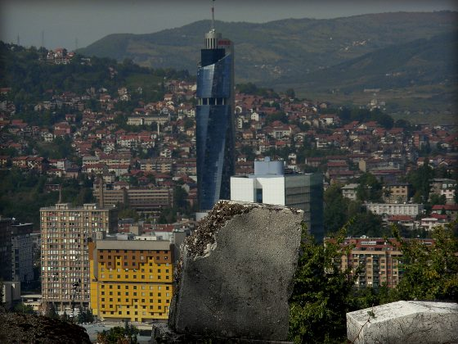

Serb snipers camped in the cemetery during the Siege of Sarajevo in the early ’90s. Most of the tombstones still carry the scars. (pizzashopphilosophy.wordpress.com 2003)

I remember a conversation he had with a Serbian man who ran away from Sarajevo. The man spouted the Serb nationalist party line - how Republika Srpska (the notorious breakaway regime largely funded and organized from Serbia) was ‘defending’ his people around Sarajevo. My father responded that maybe that man did not know everything - that Sarajevo looked more like a "city under siege... and why were Serbian forces using the heights of the old Jewish cemetery as the vantage point for artillery fire and sniper shooting at the residents of Sarajevo?!" The man remained silent.

By 1999, Vitomirovic had morphed into a respected investigative journalist; as he playfully pointed out, working as a journalist was a lot like being a spy, but with a wider audience. He had begun writing and publishing his own idiosyncratic crime publication, which he called the Timochka Criminal Review.

Almost by accident, he stumbled across an incredible story - a diver who worked for the police in specialty cases gradually related to Dragan, with the most extreme hesitation (“everyone was afraid”), what he had uncovered one night emerging from the shiny blue waters of the Danube:

I went to get the big scissors that cut iron, and when I was back, I cut the chain which locked
the refrigerator truck doors. After opening the door we experienced a shock. From the truck,
corpses started to fall out. Many corpses of women, children and old men. Some women were
dressed in shalvare (traditional Albanian clothing.) Some children and old men were naked. It
was a terrifying view... Three of the corpses were without heads.

Vitomirovic was initially skeptical of this incredible and horrific account, but the details did indeed check out. It turned out that a stone was found placed on the accelerator pedal; this was no accident. The refrigerator truck had been deliberately pushed into the river in order to cover up its human evidence. The diver’s testimony continues, in painstaking detail:

It was a “Mercedes” truck with a green cabin and a white freezer. On the side
of the truck it had markings that said it was the property of a meat processing
firm from Pec, in Kosovo, with the phone number 029-72997.

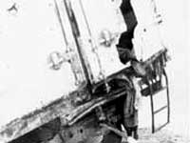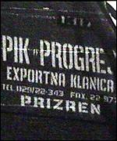

Limbs of murdered Kosovar Albanians, protruding from the back of refrigerator truck: the Kosovo connection (Free Serbia, 2001)

There could be no question where this truck and its cargo had originated. The inner cabin contained the remains of some 83 men, women and children - all civilian. Many of them, it turns out, were reportedly members of the Berisha family, killed in a brutal massacre by Serbian police forces in the southern Kosovar town of Suva Reka in late March of 1999.

Mrs.Shyrete Berisha, the courageous family matriarch, only survived by playing dead, then taking a desperate leap off the truck before the hatch was locked and sealed - despite her own severe injuries - on its way to Serbia. She had lost her entire family; their remains were later exhumed from a police training ground outside Belgrade in 2001. Despite a futile attempt to set them on fire, they'd refused to burn. They were too waterlogged from immersion in the Danube.
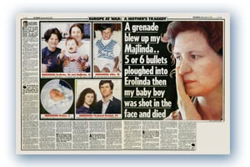’
Massacre survivor Shyrete Berisha - from Hague trial of “Kosovo 6,” 2009

Dragan’s 1999 groundbreaking article about the death-truck was initially seen by only a modest handful of readers, and all details were quickly suppressed by the Milosevic regime. But by May, 2001, Milosevic had been arrested, and as one journalist bluntly observed, “the shit really hit the fan.” The full truth about the mass killing in Kosovo and its subsequent cover-up was finally emerging, and Vitomirovic was accusing the Milosevic regime of genocide. “Covering up of a crime is also a crime,” declared Vitomirovic:

Particularly if the crime one is covering up is a serious one in respect to its causes and consequences, and if those who are covering up are the very ones who should investigate and bring the perpetrators before the face of justice, and especially if such a crime is declared a state secret.

At about this time, according to the late Aleksandar Ciric of Belgrade’s once highly respected Vreme (“Time”), Vitomirovic’s Timochka Review came out with a stunning revelation: “A truck driver known to them had transported about a thousand corpses from Kosovo and Metohija (Serbia’s traditional name for Kosovo) during the NATO bombardment.” That meant at least dozens of freezer trucks, each making multiple round trip journeys – a perverse kind of Underground Railroad of Death.

Following the intense publicity resulting from Vitomirovic’s disturbing revelations, the threats against him began in earnest, and got nasty very quickly. In early 2001, days after unsuccessfully promoting his article to a major Belgrade newspaper, Vitomirovic received a mysterious call from a man identified as “Cankovic” who claimed to be from the Interior Ministry. Dragan agreed to meet with a group of men at the Hotel Serbia in his native Zajecar.

Three agents appeared in the hotel lobby, sporting the characteristic paramilitary fatigues, as Vitomirovic later described to a fellow journalist. The meeting is worth a close examination in lieu of what was to follow. Dragan recalls:

One of them asked me about my motives for writing the article, whether I
wanted to incriminate Slobodan Milosevic. I said that I was convinced that
Slobodan Milosevic was a war criminal.

The interview gradually turns rougher and more menacing, as the men begin to admonish Dragan:

What you are doing, they warned me, was not good for the Serb nation, as it
will be condemned as genocidal by the world. And once again, you will kill those
who were in the truck (!) Then one of them started with threats. He knew that I
had grandkids, two sons... I told him that I was not afraid. I asked why some
boss or agent hadn't come. They said: 'Because you're a soft negotiator...'

The next day Vitomirovic phoned his contacts in the new government, naively assuming that the unpleasant episode was behind him. “They probably did something," Dragan later recalled, “because no one bothered me afterwards.” According to several sources, Dragan began making tentative plans to start working for Dusan Mihailovic, Serbia’s new reformist interior minister.

It was at this critical juncture that a pioneering mini-documentary was produced by an independent media team from Novi Sad, Serbia’s second largest city, highlighting Vitomirovic's findings and the subsequent attempted cover-up. The documentary skillfully weaves together multiple interview clips, a montage of intriguing reenactments, and several grainy photos of the infamous truck of death.

The film, which features Dragan’s own compelling testimony (with English subtitles), was apparently broadcast on a local television station, but just once. The work later reappeared at one or two European film festivals before disappearing. Years later this reporter accidentally discovered it posted on youtube, under the English title Travelling of the Dead. The making of the film remains cloaked in secrecy, even today.

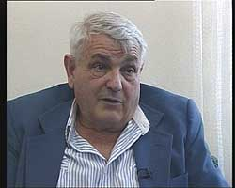

Vitomirovic, c. 1990 (Vreme)

By the end of 2002, Vitomirovic was reportedly investigating and exposing the notorious murder of three Albanian-American brothers, named Agron, Mehmet and Ylli Bytyqi. Amid the hundreds of Kosovar Albanians dumped into mass graves throughout scattered police training sites in Serbia, the brothers' bodies were unexpectedly discovered. Their remains were relatively well preserved - they were found each with a neat bullet hole to the back of the head. And these young men were citizens of the United States.

Dragan publicized this morbid scenario, and even published photos of the brothers. It was a daring and provocative act in a land where the old guard still wielded considerable power, especially in state security forces. Among these men was Goran Radosavljevic, nicknamed “Guri.” "Guri," still a free man, remains to this day the main suspect responsible for the murder of the Bytyqi brothers.

Then the bombshell: suddenly in mid-December, 2002, it was reported that Dragan Vitomirovic had been killed in a ‘car accident.’ Several journalist associations quietly demanded an independent investigation, and Radio Free Europe ran a short expose, in the Albanian language, claiming that Vitomirovic had been run off the road by a truck from the Serbian interior ministry.

But as had happened so often in Serbia, the matter was quickly hushed up and forgotten. So many ‘car accidents’ had been used to assassinate - or attempt to assassinate - so many other political dissidents. That very same week, a truck from the state interior ministry had reportedly smacked into an automobile driven by Jovo Curuvija, the brother of the assassinated journalist Slavko Curuvija. Unlike Dragan, Jovo fortunately survived.

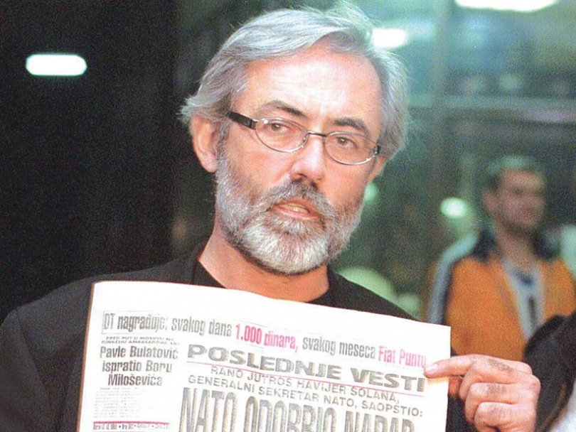

Slavko Curuvija, Serbian journalist assassinated in 1999 (Vreme)

By sheer coincidence, some colleagues and I were in Belgrade later that month, visiting the office of prominent human rights pioneer Sonja Biserko. I asked her then about the security situation with Zoran Djindjic, Serbia’s pragmatic, post-Milosevic, reformist prime minister. Sonia paused momentarily, then mentioned a small article, buried in one of their newspapers, suggesting a possible threat to the life of Djindjic and his family members.

At the time, I quickly forgot about the warning. And I barely noticed when it was reported the following February that Đjinđjić had narrowly escaped an assassination attempt in which a truck driven by Dejan Milenković, aka Bagzi, a member of the infamous Zemun Clan (a Serbian organized crime group) tried to run the prime minister's car off the road.

Suddenly, on March 12th, 2003, exactly three months after Vitomirovic’s death, Prime Minister Djindjic was assassinated. He'd been shot and killed by a high power rifle, under orders from the infamous Milorad Ulemek, also known as ‘Legija’ a close associate of Guri. For many of us, it was a shock something akin to the 1963 assassination of President John Kennedy. Many believe that a struggling democratic civil society in Serbia has never quite recovered.

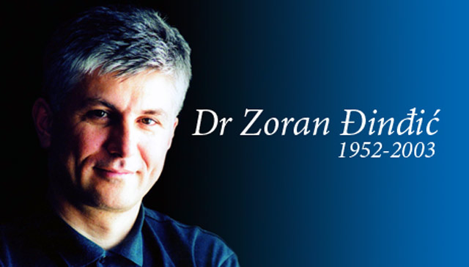

Serbian Prime Minister Zoran Djindjic, assassinated in March, 2003 (B-92)

Sadly, it took this reporter much too long to piece all of the clues together, to really comprehend how Dragan, the great Serbian whistleblower, had also been assassinated, effectively silenced by his political enemies - the same criminal clique of ultra-nationalist mafiosa responsible for so much misery throughout the former Yugoslavia.

I recently asked Dragan’s son why he had not previously pushed for a full and open murder investigation. “My father’s death and Djindjic’s assassination were very hard for me,” Miljan admitted, “and I was so depressed… I didn’t want to believe in a conspiracy theory. Dragan, in fact, had a problem with his heart and high blood pressure. But there were suspicions from the very beginning. I think he was assassinated, not by ‘fixing’ his car (as has been suggested) but with a truck pushing him off the road. I have no hard evidence, just pieces of a puzzle. I have a specific suspect, but it’s too early to talk about it.”

Miljan added one telling detail about his father’s funeral. Apparently in the Serbian Orthodox tradition, the body of the deceased is normally laid out in an easterly direction, but Dragan marched to his own, decidedly unorthodox drummer. Recalls Miljan,

Just to tell you what kind of man he was, Dragan’s grave in his native
Zajecar is opposite, as per his wishes. He also asked that over his coffin be
placed a few precious little stones he had brought back from Israel.

It’s painful to imagine that Dragan, the whistleblower to genocide, was effectively silenced, and that we who should have known better nearly allowed him - and his assassination - to be forgotten. Over a decade later, it is time for the citizens of Serbia and the world to know and admit the truth of the past, as uncomfortable as that might be.

Ironically, just as I began to research this article, I discovered that Dragan’s devoted son Miljan had written a book, just published in Serbian, called Soul on Wire. The book, Miljan declares, is “inspired by the true and unbelievable story of a man who fought with windmills all of his life." It can only be hoped that this article and Miljan’s trailblazing new work will help to ignite a very necessary conversation, and appropriately commemorate a fascinating, courageous and ultimately deeply righteous man.

As today’s post-Milosevic Serbia inches along its path towards European Union membership, it has a perfect opportunity - and responsibility - to challenge and confront the pervasive and lingering impunity of war-time crimes. EU leaders can and must foster in Serbia an independent, robust and critical press, together with a free and fully functioning judiciary. Dragan Vitomirovic and so many others like him must not have died in vain.

Robert Leonard Rope
San Francisco
Genocide Institute, Canada

“The truth is incontrovertible. Malice may attack it, ignorance may deride it, but in the end, there it is.” (Winston Churchill)

