Secrets from the Underground
How one courageous forensics doctor helped piece together an impossible mass murder mystery - while relentlessly searching for Kosovo’s most famous missing person
Imagine for a moment how you’d react if your nation had been occupied for decades by an unwelcome, hostile force. Imagine your family and loved ones subjected to an unrelenting series of atrocities, of methodically organized rapes and massacres, your landscape scarred with a swath of mass graves, some so hastily dug that weeks later blackened limbs could still be seen protruding out of shallow pits, like so many desperate pleas for help.
This is no sci-fi Hollywood dystopia. This was the dire and all too real situation for the Albanians of Kosovo during the spring of 1999, after Serbian forces loyal to Slobodan Milosevic, newly indicted for war crimes, had set fire to countless villages of Kosovo, expelling nearly a million men, women and children, and killing some 13,000 people. It took 78 days - nearly three months of intensive NATO bombing and the very real threat of an imminent ground invasion - for Milosevic to capitulate, and to gradually withdraw his forces from all of Kosovo.
For Dr. Arsim Gerxhaliu (Ger-zaul-ewe), in June of 1999 still a medical student in the field of forensics, it was a stark time, full of dread yet teeming with promise. Arsim, then only a nascent forensics medical resident, seized on this uninvited and overwhelming challenge. With brazen courage and determination, Arsim helped to transform a national tragedy into a scientific process of careful and deliberate search for Kosovo’s beloved missing. Up against an enormity of obstacles, this budding forensics doctor has led the way to the gradual but crucial identification and matching up of precious bodily remains with family members.
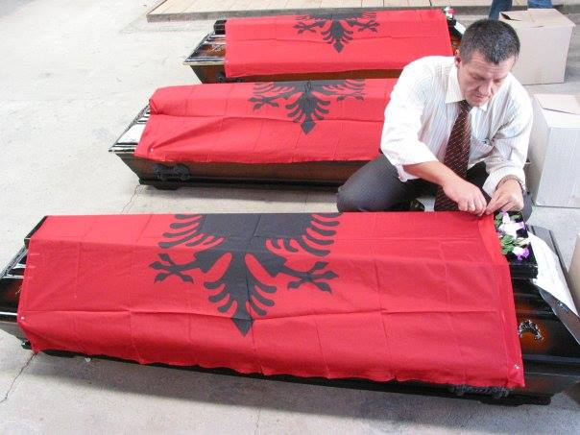
Dr. Arsim helps prepare for the formal interment of recovered remains of
Kosovo’s Missing
And for the most famous case of all - that of Kosovo’s great spiritual and intellectual luminary, Ukshin Hoti - Dr. Arsim has spared no efforts to locate his remains, to resolve Kosovo’s most emotional and painful, lingering mystery.
Always mindful of the physician’s dictum for healing, Arsim has helped offer a unique opportunity for emotional post-war closure, and a glimmer of hope for eventual peace and even reconciliation between Albanians and Serbs.
Last year my Albanian work partner and I had the opportunity to meet and interview Dr. Arsim, while taking a short break from a frenetic schedule in his forensics laboratory/office. We tracked him down at his headquarters in downtown Pristina, Kosovo’s sprawling, unpretentious capital. Arsim began by relating the exhilarating moment of liberation from enemy forces, in June, 1999:
It was my first day to get out of hiding. Sometimes you want to see something you can’t believe - and I was suddenly looking at a British flag. I couldn’t believe that they’d come. I was looking from my balcony, we were so happy. The soldiers were desperately thirsty, so I went to my garage to get water. They started to drink, they’d come all the way from Macedonia, walking, since five in the morning, and they were sleeping on the street during the night.
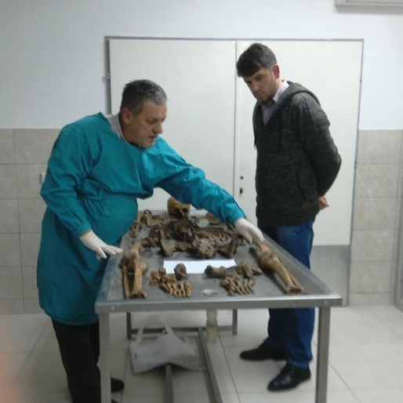
Dr. Arsim Gerxhaliu with my work partner Albinot, showing the bones of the missing, March 2015
Arsim continued, as if in a dream:
When you see such a sight, you start to feel like you are really alive. The next morning they started to continue through Pristina. I was following them. So many Albanian people were still in Pristina. No more hiding!

As Arsim described the moment, it began to echo the liberation celebrations of Paris from Nazi occupation in 1944: “It was like being born again,” he insisted. “The first time you are not aware of being born, but the second time your brain cells have matured, you see that you are born, again.”

Dr, Arsim followed closely behind the British soldiers, and quickly came upon the first visible evidence of atrocities:
We went to a village outside Pristina, that was my first contact with the bones, with dead bodies. I saw the corpses lying near the road, buried very superficially by the Serbs. Some of them, they were just rubbished on the other side of the river. In one case, only an arm was left uncovered, the rest was buried.

Even with all of the ominous news reports, no one was quite prepared for what awaited them:

We walked on a little bit, there was a garage, and some kind of saw used to cut wood. Some of those hiding in the mountains informed us that many people were killed in this garage. The garage was full of blood, but no bodies, just blood. You could see the blade. Many international journalists were there, with all the blood smeared onto the walls.

Post-war Kosovo was overflowing with mass graves of every size and shape, including countless wells, now contaminated, where bodies had been hastily and conveniently dumped. But that didn’t explain the whole picture. What had become of the many hundreds of Kosovo’s remaining missing? Terrible rumors abounded of refrigerator trucks and secret convoys of death moving across the border into Serbia - rumors which gradually gave way to facts on the ground once Milosevic was finally overthrown.
It turns out that in the black of night and under the cover of NATO bombardment, fearful and coldly determined to cover up evidence of war crimes, Serb forces commandeered surreptitious convoys of hastily requisitioned local refrigerator trucks. Special forces then transported the bodies of murdered Albanians to scattered sites inside Serbia: Petrovo Cela, Lake Perusic, even dumping an entire truck with its contents directly into the Danube River. But the vast majority of bodies ended their macabre journey at the Batajnica police training grounds, just outside of Belgrade.
Dr. Arsim picks up the story:
Starting in 2001, there was an official request to visit the mass gravesites in Serbia. This happened because three American citizens had been killed in Serbia, after the war’s end - the Albanian-American Bytyqi brothers (a criminal case still unresolved.) In 2002, I traveled to Belgrade, when we started the first transfers of the bodies from Batajnica and Petrovo Cela back to Kosovo.

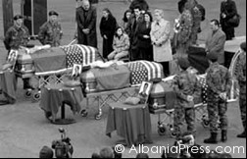

Funeral for the Bytyqi brothers, held in the USA
(March 5, 2002)

Listening to Arsim, it became clear that none of this had transpired in a timely fashion. In addition to all of Serbia’s bureaucratic, stalling tactics there was the problematic issue of DNA identification by international experts. The ICMP (International Committee for Missing Persons) is located in nearby Bosnia, its offices and state-of-the-art labs centered in Sarajevo and Tuzla. Since the war and genocide in Bosnia (1992-5), they had become responsible for undertaking the DNA analysis and identifications for the entire region, and had an exclusive contract with Serbia and the UNMIK (formerly United Nations Mission in Kosovo.)

According to Arsim, international law dictates that no bodies may be transported without first undertaking appropriate identification, which can take months or even years. This led to a vicious, Catch-22 situation, and an extremely high level of frustration for the Kosovo family members of the missing, and for the society in general, still suffering from a form of communal post-traumatic stress. Arsim insists that he remained vigilant about return of the bodies: “All the time I pushed that I wanted all of them:

The ICMP took donor samples of 2,900 families from Kosovo, including at least three (genetically related) members from each family. We found them here or in Europe, in Germany. Analysis was done, the first transfers involved eight bodies, from 2000 until the 30th of June, 2006. That was the last transfer - at that point we just decided to take all the bones, whether they were identified or not.

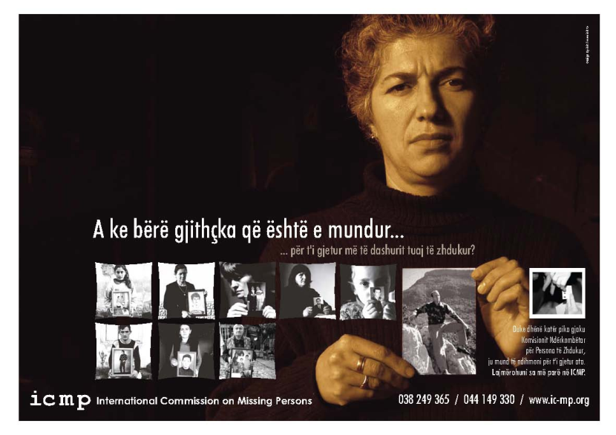
ICMP poster in Kosovo - by the end of the Kosovo conflict in June 1999, it was estimated that
4,400 to 4,500 persons were missing. Today, about 1,700 remain unaccounted for.

All told, between 2000 and 2006, over 800 identified remains, together with scores of others not yet identified, were eventually returned from Serbia, mainly originating from the Batajnica police training center. Batajnica was a surreal landscape, featuring nine well secured and discrete mass grave sites, flanked by hidden tunnels. Some of the bodies had been previously buried and then hastily excavated and reburied at Batajnica - others were brought straight from the killing fields of Kosovo in Spring, 1999, and dumped directly into one of the pre-excavated holes.

Still other massacre victims had traveled on one of the infamous refrigerator trucks that had been dumped directly into the Danube, which unexpectedly resurfaced just a few weeks later. Covering up genocide requires a bizarre and complex mix of unending drive and desperate ingenuity, as Arsim came to witness directly:

Near Batajnica were 10 tunnels, from 30 to 50 meters, dug by the Germans between the 1st and 2nd World War, in order to grow mushrooms. Beginning in 2000, after Milosevic was deposed, the Serbs began exhuming the Batajnica site. There were ten doors in the side of a hill. They put the bodies into bags, and moved them into the tunnels.

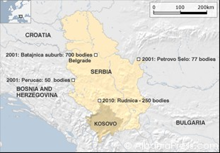
Map highlighting mass graves of Albanians inside Serbia, 2010 (BBC)
As Arsim came to understand, Serbia had no access to massive freezers, and the pre-built tunnels protected the remains while strategically keeping them out of public view.

I asked Dr. Arsim if it were true, as we had heard, that Serb authorities had been keeping him at a distance, whenever possible. “Of course,” he snapped, as though I were asking the obvious. “All the time they were keeping us at a distance. But one Serb doctor was trying to show me that he felt regret. He led me to the tunnels. I think he was trying to make some kind of personal amends.”

The conditions at the Batajnica exhumation were brutal. Under the merciless Balkan sun, the temperature hovered at over 100 degrees fahrenheit; inside the tunnels it was cold and damp. It all took a high toll on the workers, especially considering the grueling and sensitive nature of their work. I asked Arsim how he felt doing such torturous work, but I was utterly unprepared for his harrowing remembrance upon discovering the remains of one small girl:

Exhuming bodies at Batajnica, c. 2001

It is one of the first times in my life, I cannot forget what I saw. I was in front of her - a
small girl with a bullet to the head, very typical. Maybe she was from the massacre at Suva Reka, I’m not sure. There was the tunnel (gesturing) and a bag, like the kind we use for tomatoes, for her clothes. It was becoming moldy, decomposing.

I opened the plastic bag, with her remains, with her skull, the skull of a 7 year old girl.
They had already exhumed the remains, and had left the bag with the clothes near her.

Dr, Arsim paused, and I began to wonder if I should have left well enough alone. But there was no going back, and he was speaking as if in a kind of trance, as though he had never related this story to a living soul:

I started feeling my heart beating quickly. The bag was decomposing, and the right side of her jacket was sticking out. I touched the jacket, and I heard the voice: ‘Where have you been? Why are you so late??’ It was my first time to be alone there, to hear the voice. Like she was asking me...

I knew that Dr. Arsim was a highly professional scientist, and top in his field. But he’d also personally lost 47 members of his own family during the mass killing. It was simply impossible not to be intimately affected by such work. Arsim continued:

It was the girl’s voice I heard. She was asking me: ‘Why didn’t you come earlier??’
That second, not by my wish, I started to cry. Tears came pouring out of me. My
hands became wetter now, just talking with you.

For many years such findings at the Batajnica site took up most of Dr. Arsim’s forensic attention; aside from a few other sideshows, it was clearly the main attraction. But something was askew. Suddenly in May, 2010, it was announced across the international media that a new mass gravesite had been “discovered” inside Serbia at the southern region of Raska, less than 25 miles from - as official Serbia still refers to it - the administrative border with Kosovo. The Raska site was allegedly filled with the remains of some 250 Kosovar Albanians.

BBC’s website, for example, assured the world that the Raska mass grave was based on reliable evidence, and featured a special map with a highlighted red circle delineating the house and adjoining lot that was allegedly covering up the bodies.

When this news hit, I was already deeply involved in researching and writing about Balkan war crimes - in for the penny, in for the pound, as the Brits like to say. In the spring of 2012, we met with an official of the EULEX (European Union’s Mission to Kosovo) war crimes division, who assured us that yes, they stood by the Raska allegations, although they claimed to have no mandate to actually do anything inside of Serbia.
It was a time of extreme frustration for me, and many Chetnik (Serbian extremist) detractors found unending mirth with our ‘imaginary’ mass grave, as they claimed repeatedly on various websites. I presented my case to Dr, Arsim:

To be honest with you, we got this information since 2004. But never was Kosovo
the owner of the remains, nor had we the right to exhume this area or to make
decisions. We created these working groups, like we were working with the Serbs, and had regular meetings since 2004. But always we were under UNMIK, EULEX, ICMP.

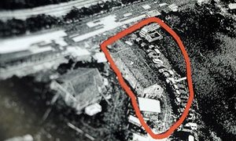
An aerial photo of the site of a mass grave in Serbia believed to contain the bodies of 250 ethnic Albanians. Photograph: Andrej Isakovic/AFP/Getty Images
The uncomfortable truth was that the international community, such as it is, never allowed Arsim and his Albanian colleagues the freedom of exploration they so desperately required. I asked him to describe the Raska site and its history:

They built a house - there’s a small lake - roads, tracks, extending over a space of 300 meters by 200 meters. Satellite imagery showed the territory, but it’s so high up and unclear about specific locations. In 2007, they left us to check one place; after that, in 2009, somewhere else; in 2010 and 2011, yet somewhere else (pointing to a map.)
Reluctantly, I confronted Dr. Arsim directly: why didn’t you just check under the house, like it shows in the photos? I sensed that his patience with me was beginning to wear thin:

As I said, I got this information in 2004, but we never had permission from the Serbian prosecutor to exhume that specific area. Before we could demolish the house, we took soil samples. Verbally they told us: no organic substances, but we never got any official report.

This was all just too much for me. I remembered, all too well, those discouraging days - the search for the bodies, the obfuscation of Serbian officials, the confusing and ambiguous results of the ‘organic’ soil samples. My personal and very American feelings were threatening to overpower the interview, and Dr. Arsim felt a swift intervention was in order, and he wasn’t concerned with American political correctness: “Yes, my friend, but we are dealing with Serbs… To cut your pain, because I had this pain 16 years.”

I was appropriately chastised. Dr. Arsim returned to his narrative:

Now, with the last order, in 2013, they let us go near the house. We were insisting to destroy the house, they said “No!” At first, they would not bring the promised excavators. So I went to the media and fought back. I was at risk, fighting with the Serbs. But 70 centimeters from the house, on 13th of December, we found the first human remains. After that we destroyed the house, and found everything. The bones were buried 40 to 50 centimeters deep, under the asphalt parking lot.

In the midst of all these grizzly skull and bones revelations, Arsim presented us with an unexpected mystery, approaching the complexity of an Agatha Christie who-done-it: why had they found two of the early would-be mass grave sites (Batajnica 8 and 9) empty? For once, I was stopped short. Perhaps to trick us? To throw us off track? The answer will surprise you:

It took us 16 years to figure it out: At the beginning, the Serb forces didn’t transfer bodies along the main highway through Nis, because NATO was bombing there. Instead, the bodies were brought along the alternative Ibar Road. In Raska we found 53 bodies. Many were from Drenas and Rezala, in eastern Kosovo. One of the bodies does not match with any donors in Sarajevo - maybe he was a ‘guest’ who just happened to be there. We don’t know who he is.
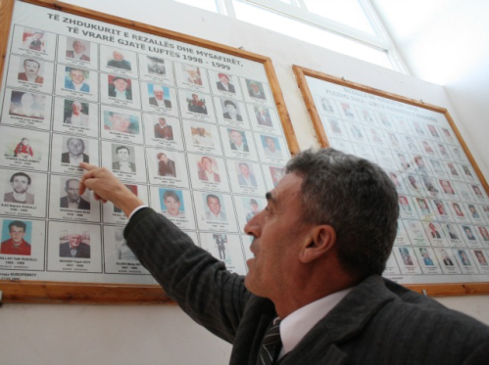
Rrezalle/Rezala school director Bajram Rrukolli with a memorial to villagers killed in the war. (Photo: BIRN)

Dr Arsim, now with his Sherlock Holmes master detective identity, continued:

So, half of the victims from Rezala, from the 5th of April massacre, were found at Batajnica, and half were found (much later) at Raska. Through the NATO satellite images, we knew, after the 25th of May 1999, these bodies traveled to Raska. Why? Because on May 24th, the Ibar Road was bombarded - so these people who were planned to be sent to Batajnica 8 and 9, instead went to Raska.
Later it was determined that 19 of the bodies exhumed from the Raska site belonged to the Morina family from Cikatova e Vjeter, killed in yet another massacre some 12 days after the killings in Rezala. Sixteen years later, to the day, these bodies were solemnly buried by family members - the 17th of April, 2015.

"The strange thing is that this happened in Europe, this happened in the Balkans,” commented one of the surviving Morina clan, in a recent Al Jazeera article. “The strange thing is that the new government in the country that committed these crimes is not apologising, is not saying even sorry for the crimes that they have done." It means that even when the bones are discovered, exhumed and identified, the authorities in Belgrade remain reluctant to acknowledge even a glimmer of responsibility.

So one murder-mystery was at last resolved. But just like in a scavenger hunt, as soon as one riddle is resolved, another one stubbornly pops right up. There remain some 1,665 missing persons from the Kosovo war, including over 1,100 Albanians and about 500 non-Albanians (Serbs, Roma and others), 16 years after war’s end. So I had to ask: Will all of these remains ever be recovered? Dr. Arsim hesitated ever so slightly, then delivered the unanticipated gut-punch:

Some of them - not all. I have reasons to say so. In talking with Natasa Kandic (formerly of Belgrade’s Humanitarian Law Center), we understood that some bodies were cremated in industrial furnaces like Trepca, Mackatica and Bor.

Surdulica, Serbia – Mackatica factory complex - and alleged crematorium for missing Albanians

“But,” Dr. Arsim continued, “we are not talking like that, because when Alan Robinson stated in EULEX’s 2011 annual report that approximately 300 - 350 bodies were burned, and will never be returned, the families wanted to kill him! The Kosovo families won’t accept it.”

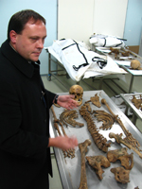
Alan Robinson, forensic pathologist, formerly with EULEX

For one rare moment, I was stunned into silence. Slowly I found my composure. The Kosovo families won’t accept it? Okay, I’m sorry, I understand. But the truth is more important than some mere feelings! And the truth was that we had already written about these cremations, a detailed report entitled Burning Secrets of the Balkans. Yet when we’d visited EULEX, they never came forward with such information. I had never even heard of Alan Robinson, never found this candid admission of Serbia’s culpability in the mass cremation of bodies.

It was an especially painful moment of recognition. Somebody is playing games with us, I mused, and there is absolutely nothing we can do. I was reminded of a quote by the Buddha: “Three things cannot be long hidden: the sun, the moon, and the truth.” In this case, the Buddha seems to have missed the target. Sometimes the truth just does not win out.

Finally, the conversation drifted to the most famous missing person of all - Kosovo’s beloved Ukshin Hoti, the spiritual father of Kosovo Albanians. He disappeared on May 15th 1999, and has not been seen since. It turns out that Arsim had known Hoti, intimately:

Nobody knows him better than me. We were neighbors from the year 1970. He was our first neighbor… We were very close to him - he was a very good man. After he married his first wife, Edi Shukriu, professor of archaeology, they had a daughter, Erleta, in 1981. This was the time of the student demonstrations.

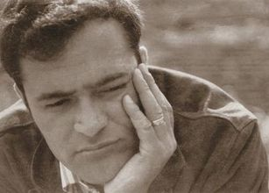
Kosovo’s beloved Ukshin Hoti

After a few months, Hoti was arrested and the Serbian police put him in prison, together with his wife. Erleta was only a small baby, just a few months old. Arsim himself was only in middle school at the time, and arrived home from school just as the arrest was in progress:

I was coming home from school with my books. I told my mother that the Serbian police had arrested Ukshin. They gave the baby to me - the police were there, Hoti lived in flat number 7, we were above. Ukshin held out his hand to me. He was very special: ‘How are you, how were things in the school?’ He was talking like normal, how’s school? like everything was normal. He was really an exceptional person.

Now I am killing my brain cells… He didn’t care about normal ways (switching temporarily into Albanian.) After that, I took the baby, gave her to my mother. Mother cared for her.
Half of her life, Erleta was in our home. She is grown now, and has stated publicly that she had two families: ‘One family is my Hoti family, and the other is the Gerxhaliu family, because they cared for me when my parents were in prison, during the Yugoslav system.’

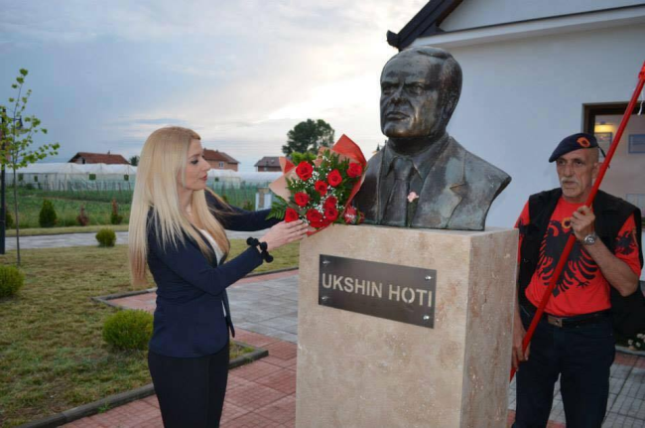
Hoti’s daughter, Erleta, at her father’s memorial

During the war, Hoti was locked up in the notorious Dubrava prison, until May 15, 1999. On that day, he was released, and offered his parting goodbyes to his friends there. Since that point, everything else concerning Hoti’s fate is speculation. According to Dr. Arsim we are left with only mixed and contradictory evidence:

Some of the witnesses said they heard loud noises - bam bam bam!: After that, there was a body outside Dubrava, a body without a head found outside the prison, with his clothes, they said. But Hoti’s sister claimed it wasn’t him, after the war.

“I have a very short video recording,” explained Dr. Arsim, “not well focused. The recording was so short - you can see a body, without a head. I don’t know… The last information about Ukshin is that maybe he is in one of the prison reservoirs. We will try to empty them, which are three or four outside of Dubrava prison, and one inside the territory of the prison.”

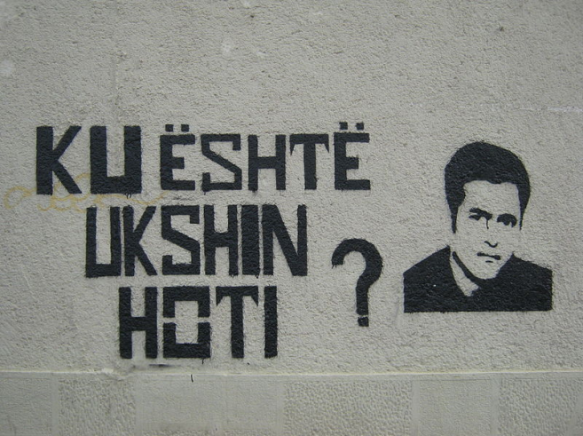
Ku është Ukshin Hoti (Where is Ukshin Hoti) - Graffiti in Pristina

In truth there’s been a swirl of rumors, over the years, regarding the whereabouts of Hoti’s remains. Several different people from Serbia have promised to pass on confidential information to help find Hoti, in exchange for an unspecified amount of money, or for a certain trade-off of information. None of these leads have proven fertile, and some have left added pain and anguish upon Hoti’s friends and family. But the rumors stubbornly persist.

It wasn’t easy to leave Dr. Arsim at interview’s end. He appeared relieved enough, as though he’d just managed to survive the Spanish Inquisition, American style. Speaking strictly for myself, I felt like I’d been in the presence of the Magic Man - the Healer of Lost Souls. Returning to everyday, ‘civilian’ life seemed hopelessly mundane, utterly lacking in meaning.

That was one full year ago. Since then, I’ve listened to and reviewed Arsim’s interview on numerous occasions, transcribing segments, contemplating all of those mass graves: the missing from the Balkan genocides, my own people from the Holocaust, along with so many other victims of genocides. I, too, hear voices sometimes, late into the night, scolding me and pleading: Where have you been? Why have you come so late? Those voices haunt me, and push me forward, despite all of my many personal failings and vulnerabilities.

Apparently some young people in Belgrade have also heard these voices. Recently, a group of some 20 young activists from the Serbian dissident Youth Initiative led a public march to the Batajnica mass grave site just outside of Belgrade. The march took place on the 17th anniversary of the killings of 48 Kosovo Albanians in the village of Suva Reka; 46 of them were members of the Berisha family, including 14 children under the age of 15, two babies, as well as a pregnant woman and an elderly woman. That mass killing, one of the most notorious massacres from the war, continues to be litigated inside Serbia’s turgid judicial system, up until today.

Official Serbia may continue to throw an opaque shroud over war crimes and war criminals, and the Serbian media and masses may ‘hate dwelling on the past’ as one handsome youthful Dutch tourist confidently confided to me on a recent trip to Belgrade. But the Youth Initiative activists, besides reaching out to their Albanian peers in Kosovo, are determined to dwell on and publicize the bad old days, at least until their fellow countrymen awaken from their deep and troubled conscience-impaired slumber.

There’s even a new pioneering documentary film, BIRN’s The Unidentified, which investigates Serbian command responsibility for some of the most brutal attacks of the Kosovo war, and the culture of impunity that remains so prevalent within Serbia’s power structures. The film has played throughout the former Yugoslavia, include Belgrade, and in select festivals worldwide. Perhaps the Buddha is right after all - the sun, the moon and the truth cannot be hidden forever.
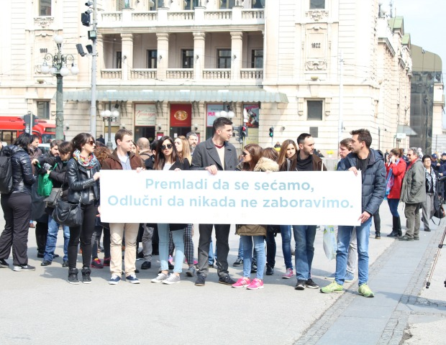
Belgrade’s Youth Initiative, trying to awaken their fellow Serbs from a deep slumber:
"Too young to remember, determined never to forget"
(Balkan Insight)

Robert Leonard Rope
San Francisco
May, 2016
Institute for Research of Genocide, Canada

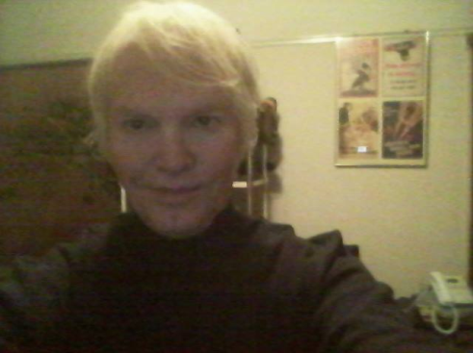
Robert Leonard Rope is a freelance journalist residing in San Francisco. His past articles include: Burning Secrets of the Balkans, War Crimes and Cover-Up and The Whistle Blower. He is currently at work on a book about genocide in the former Yugoslavia during the 1990s.

