Never Again Productions Inc.
October 19, 2016

Mr. Ramic
Institute For Research Of Genocide Canada

Dear Mr. Ramic,
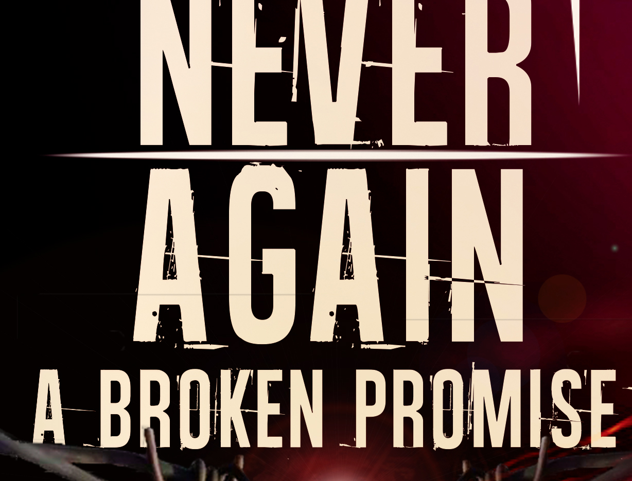
My name is Yolanda Papini-Pollock and my partner's name is Rogers Ofime. Rogers is an award winning producer from Nigeria that immigrated to Canada about 5 years ago. We are independent producers that have a real interest in the genocide subject. We are putting together a proposal to create a docu series (13 episodes) about genocide and persecution and we are certain that we could find funding support from TV outlets and the government of Canada. We would like to follow survivors of specific genocides, look at their story from a historical point of view and tell their personal story. We would like to show how Canada, by opening doors to refugees, allowed them to flourish, thrive and contribute to society. One of the episodes will focus on the genocide in Bosnia- Herzegovina and for that we need to identify survivors living in Canada as well as experts that could shed light from an academic point of view. I am wondering if you could help us locate them?
867 Queenston Bay Winnipeg Manitoba Canada R3N0Y1
I look forward to hearing from you.
Sincerely,
Yolanda Papini-Pollock
This is a trailer for our pilot episode that was premiered last month: https://www.youtube.com/watch?v=ST4ynjprpzM

Never Again: A Broken Promise is a documentary that details the experience of four local victims of genocide. The film was written and produced by a group of passionate filmmakers from different ethnic, religious and socio-economic backgrounds. The film's executive producer, Yolanda Papini-Pollock, wrote the script and Rogers Ofime directed it.

The phrase “Never Again” emerged at the end of World War II when survivors of the Holocaust vowed to never allow innocent Jews to be persecuted. This phrase is now universally used to fight any form of genocide. However, the film shows how the promise of "never again" has been broken repeatedly in modern history.

The documentary is jarring as it examines the accounts of the survivors. Although the Yazidi Genocide is the central focus, the film also examines the Holocaust, the Rwandan Genocide and Residential Schools. These heart wrenching accounts are paired with interviews of local scholars.

The film raises awareness while also educating viewers about genocide. In the end, viewers learn specific characteristics of genocide. The documentary issues a call to action, urging viewers to raise their voices against oppression. We each have a responsibility to make a difference especially when innocent people face injustice.

