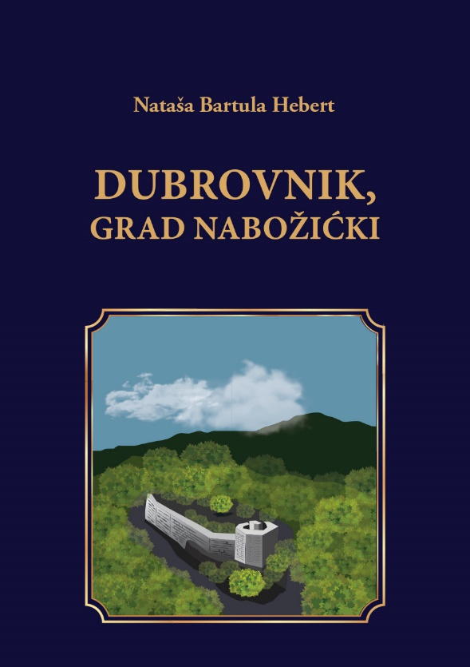

DUBROVNIK, MEDIEVAL BOSNIAN CITY

Dubrovnik, Medieval Bosnian City, is a historical novel that delves deep into the events of the Middle Ages through the history of a medieval city in Bosnia.

Dubrovnik serves as a mirror for the novel's narratives, containing stories surrounding the medieval Kingdom of Bosnia: a time when Bosnia was at its military and territorial apogee. The novel describes essential details regarding the relations of the Bosnian rulers of that era with Rome, Hungary, Serbia and the Ottoman Empire.

The novel centers on the story of the unfortunate fate of Queen Katarina Kosaca, wife of King Stjepan Tomas Ostojic Kotromanic. The story also describes the lives of Bosnian nobles, among them Grand Duke Herceg Kosaca, the father of Katarina Kosaca. The Ottoman Sultan Mehmet II, known as the Great Conqueror, is also widely represented in the novel through his relationship with his mother-in-law Princess Mara Branković, wife of Mehmet II's father, Murat. The life story of Princess Mara's father, the Serbian despot Djuradj Brankovic, is also part of the intrigue, as is the fall of Serbia.

It also tells the story of the Grand Dukes of Bosnia: Mirko Radojevic, Batic Mirkovic and their descendants, including Paula, first confidante and companion and friend of Queen Katarina. The complexity of this era is well represented, including the Bosnian Church and the disappearance of its members from these areas. It inevitably touches on the reign of the Bosnian kings and their position of unenviable dualism on the border between East and West. The end of the novel is marked by the tragic story of the last Bosnian ruler Stjepan Tomasevic, and the tragic end of Bosnia itself, as well as the heartbreaking story of Queen Katarina's departure from Bosnia and the forced removal of her children to Istanbul.

It is a story based on historical facts, embellished with lyrical elements as well as fictional characters, aiming to enrich the account and entice the interest of readers. Additionally, the fictional characters allegorically and metaphorically represent the real phenomena and events of that era. For example, through the fictional characters of the Knights Radas and Miltos, the novel composes a realistic image of the Knights of that era: the code of honor, patriotism, faith and honesty, physical strength, and all the qualities morals that distinguished the knights, making them powerful squires and pillars of the Bosnian army. At the same time, the love between one of the main heroines, Paula and the Knight Radas, as well as the beautiful love story of the Knight Miltos and Mara give the novel a romantic side, necessary to embellish the image of a dark and difficult period. The role of women is particularly difficult in this era where women are classified into a few simple categories: wife, mother, or as virgin, nun, wife, or widow. From this, it is clear that a medieval woman's happiness depended on marriage.

Elements of romanticism in fiction, mixed with realism, serve to elevate the most important elements of life: love, faith, constancy, courage, commitment, and also to attract the attention of all kinds of readers: from those who are perhaps less interested in the historical structure of the novel, to those readers who are on the other hand intrigued by history, as well as historians.

Thus, the novel has a universal character with a universal message engraved on the monumental Bosnian medieval tombs: pride, patriotism, nobility, courage and perseverance of tormented men throughout the ages. “No one will ever destroy the stone of our existence,” Knight Radas reminds his son fleeing the Turks who conquered Bosnia.

On Nabozic Mountain, where the medieval city of Dubrovnik is located, the descendants of the great Knights, Counts Mirko Radojevic and Batic Mirkovic carry the glory of those authentic times and events in medieval Bosnia towards the end of their reigns. The story of Knight Radas Mirkovic, the nephew of Grand Duke Batic Mirkovic, provides a vivid picture of this era of kings, nobles, castles, knightly tournaments and the chivalric code of patriotism and honor. Paula Mirkovic, born in the medieval city of Dubrovnik, is one of the main heroines: the future wife of this Knight. Paula, with the strength of her spirit, metaphorically represents the strength of patriotism of a woman who manifests her love for her homeland, her queen, her family and her brother, with her faith in God. Paula, after several years of living in the Convent of St. Claire in Dubrovnik on the sea (present-day Dubrovnik in Croatia), leaves the convent and marries her first and only love - the Knight Radas. The crown of their love is their son Zvjezdan, who, like many boys of that time, was taken to become a Janissary, according to the Law of Devchirme. He will return as a young adult, as a Janissary, one of the Sultan's guards during the occupation of Bosnia, where he will join his father, mother, and Queen Katarina when he finally leaves Bosnia.

The theme of slavery, still present at this time, is also represented in the novel. This theme is realized through the character of Grlica Misljenovic, who was taken as a slave to Dubrovnik on the sea. It is common knowledge that slavery continued throughout the Middle Ages, even after the collapse of the social system of slavery.

Thanks to the developed psychology of the characters, the novel clearly reflects the image of the personality of women in the darkness of the Middle Ages. They characterize the deep loyalty of the female victim subjected to a strict patriarchal upbringing. Heroines who rise to the pedestal as victims, showing the genetic strength born from love for family, children, and homeland.

Medieval Bosnia of the time is also revealed with the discovery of the history of Dubrovnik, a medieval city, with its knights, kings and queens who come to life in the stories. The ancient tombs on Nabozic Mountain, dormant for centuries, watching over time, are now taking part in this historic resurrection. The oaths of the knights live again through the beauty and strength of the infinite, to honor those who were, those who are, and those who will be. Water flows again from the stone fountain in the ancient medieval city of Dubrovnik. The sound of the hammer and the anvil is heard again from the ancient forge, the miners have woken up to the sound of the pickaxe, and the children are shouting on the cobblestones. Cherries, linden, and mountain grass once again cover the landscape, and the streams overflow. Eagles also appear in the sky of Nabozic Mountain, recalling the song of the Kingdom of Bosnia and the fall of medieval Dubrovnik.

The last king of Bosnia, son of King Tomas, Stjepan Tomasevic, tragically marked the history of the Kingdom of Bosnia. The novel ends with the collapse of Bosnia, which, as the people said, "fell with a single whisper" before Sultan Mehmet. This is best explained in the chapter about King Stjepan, who, along with his uncle Radivoje, was captured while fleeing Bosnia. During his escape he found himself in the town of Kljuc, one of his fortress towns. A few days later, after ordering the surrender of the other fortifications to the Sultan, he was executed in Jajce.

Queen Katarina Kosaca Kotromanic, Paula's mistress and friend, is one of the most tragic characters in the novel. The sad destiny of the widow is followed by the loss of her children into Turkish slavery. With the fall of Bosnia, she lost both her children and her homeland.

Queen Katarina remains alive, goes to Rome, but without her children and without the kingdom. She carries with her only one legacy: the royal silver sword that she keeps for her son, should he return, as well as the hope that her children and her lost kingdom will be returned. She never returned: she died in Rome; a sad queen without a kingdom, a mother without children.

“My kingdom”, Katarina whispers her last words of farewell to Bosnia, “you are nothing but a pure widower without a king, an orphan torn from his mother's knees. What else can I say to you other than remember me through my good deeds? I, Katarina Kosaca Kotromanic, your sister in pain and an orphan myself, have nothing left to give you except the promise that I will not leave you forever!”.

She fell silent, letting the tears fall down her pale cheeks. The wind also died down. And the rustling of the birches stopped. The murmor of the spring seemed to have stopped for a moment. In the holy silence, the tip of the sword flickered, shining for a moment. It sparkled for a long time, emitting a soft sound reminiscent of the whispers of the sovereigns who carried it through the centuries of Bosnia.

